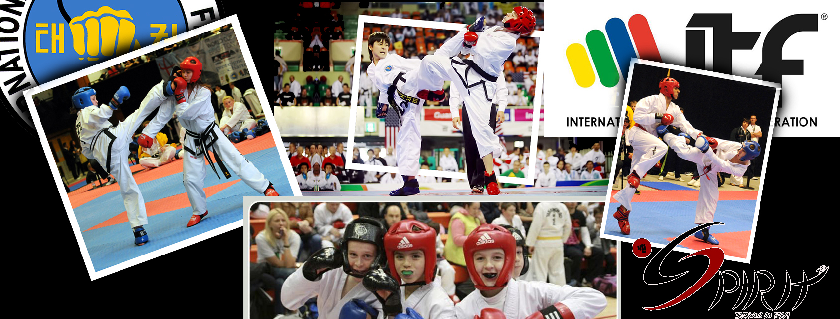
11th - SPIRIT OPEN
2022
MOGYORÓD, HUNGARY

Competition: | 11th - SPIRIT OPEN – Open ITF Taekwon-Do Championship – 2022
Organizer Association: | TKD Spirit Association
Head of Organizing Committee: | Péter Szász 6th Degree  +36-20-398-5391 e-mail: szasz.peter.tkd@gmail.com
Information: | spiritopen@tkdspirit.hu  www.tkdspirit.hu  Facebook event: https://www.facebook.com/events/696396634694137/
Members of Tournament Committee: | Attila Solti 6th Degree, Attila Gombos 6th Degree
Date of the Competition: | 9th April, 2022
Location of the Competition: | Grosics Gyula Sportcsarnok / Gyula Grosics Sporthall  Mogyoród, Iskola út 5., 2146 Hungary
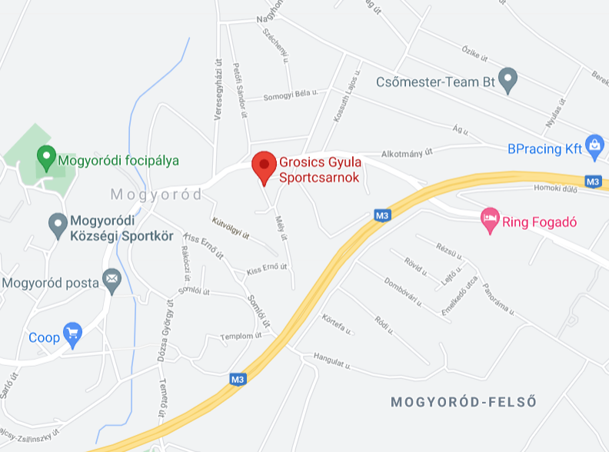
Divisions: | Children: born after 09.04.2012  Cadet: born between 09.04.2008 and 08.04.2012  Cadet-1 (only in Sparring): born between 09.04.2010 and 08.04.2012  Cadet-2 (only in Sparring): born between 09.04.2008 and 08.04.2010  Junior: born between 09.04.2004 and 08.04.2008  Senior: born before 09.04.2004  Veteran: born before 09.04.1982 (only in Sparring and Pattern categories. Veterans and Seniors will compete together in Pre-arranged Free Sparring, Special Techniques and Power Test categories. Competitors registered as Veterans may choose if they wish to compete in the Senior or Veteran categoies in Sparring and Pattern events. It is possible to choose to participate as Veteran in one, while participating as Senior in the other one. (So for example participate as Veteran in Sparring while participating as Senior in Pattern, or the other way around.)

Events: | Pattern (Children / Cadet / Junior / Senior / Veteran categories for ITF Taekwon-Do competitors only)  Sparring (based on the official ITF Taekwon-do rules in Children / Cadet-1 / Cadet-2 / Junior / Senior / Veteran categories)  Pre-arranged Free Sparring (based on the official ITF Taekwon-do rules Junior and Seniors compete in the same category, pairs can even be mixed between the two categories. Only for ITF Taekwon-do competitors, male-male, female-female or male-female pairs are also accepted.)  Individual Power Test (based on the official ITF Taekwon-do rules in Junior / Senior categories and with special cushioned force-measuring Power Test target in Children and Cadet categories)  Individual Special Techniques (based on the official ITF Taekwon-do rules in Junior / Senior categories with traditional techniques, while for Children and Cadet categories only Twimyo nopi chagi)
Minimal belt degree for Pattern: | Children: 10 gup  Cadet: 9 gup  Junior: 8 gup  Senior: 8 gup
Awarding: | In Sparring at Children age category we will form groups of 4 children, so every Child competitor wins a medal (one 1st place, one 2nd place and two 3rd place).  Children Pattern and Cadet (Cadet-1, Cadet-2), Junior, Senior and Veteran categories will all have one 1st place, one 2nd place and two 3rd place awards.  In Individual Power Test and Individual Special Techniques there is no shared third place, except in the case of a tie in points.  The three most successful clubs will receive trophies at the end of the competition. (Based on Sportdata calculations.)
Umpires: | Every ITF Taekwon-Do school or club with more than 5 competitors should bring umpires as far as possible.  Dress code for umpires: navy blue/black pants, white shirt, blue/black tie, white shoes.
Entry conditions: | Proper age.  Signing up in time and the payment of registration fee.  Medical certificate for the competitors, which will be the responsibility of the club leaders, and which we will check during sign up.

Registration fee: | Paid on the spot on 09.04.2022:  In every age category the first event costs 8000 HUF (25 EUR) and every additional event an additional 2000 HUF (5 EUR). So running in 2 categories costs 10000 HUF (30 EUR) running in 3 categories costs 12000 HUF (35 EUR) and so on.  The registration fee for pre-arranged free sparring is 2000 HUF (5 EUR) (1000 HUF per competitor).
Registration deadline: | 05.04.2022 24:00
Registration:  Modifications: | The registration for this event must be done online through Sportdata: https://www.sportdata.org/taekwondo_itf/set-online/index.php  The online registration is required, the Organizing Committee cannot accept any registration requests or changes in other ways, but if you need any help in connection with the registration please do not hesitate to contact us. (spiritopen@tkdspirit.hu)  Each club leader or coach has to register his club in the Sportdata system, then has to register all of his competitors, so then he can add the competitors to the event.  The registration will close at midnight on 05.04.2022, after this deadline changes can only be accepted with the conditions mentioned below.  Modifications will only be accepted from already registered teams, with the payment of modification fees. Any modifications should be noted during the registration before the competition. The fee is 5000 HUF (15 EUR) per competitor.
Weigh-in and On-site Registration: | All competitors of the club (only those participating in Sparring) must come to the weigh-in at the same time, together. At the weigh-in the club leader (or designee) must be there. Weigh-in will only happen at the given time, past this point there will be no possibilities for weigh-in.  Competitors must wear ITF dobok trousers or sweat pants, T-shirt and must be barefoot or in socks. There is no time for changing or undressing at the weigh-in.  A margin of at most 500 grams over the indicated weight category is permitted. In case of a competitor’s weight surpassing this limit of their category, the competitor can switch weight category, but this will be a modification (mentioned above).  After weigh-in the club leader registers all the competitors at once at the Registration desk. The club leader must pay all the fees and any possible penalties in one payment. Individual registration and entry fee payment is not possible. The competitors may only start the competition if the club leader has already paid all the fees of the whole club and handed out the received armbands to the competitors. Every competitor must wear the armband. Every competitor without an armband will be disqualified.

Event descriptions

Pattern
 | Child | Cadet
10-9-8-7 gup | Chon-Ji – Do-San | n/a
9-8-7 gup | n/a | Chon-Ji – Do-San
6-5-4 gup | Chon-Ji – Joong-Gun | Chon-Ji – Joong-Gun
3-2-1 gup | Chon-Ji – Choong-Moo | Chon-Ji – Choong-Moo
I.dan | n/a | Chon-Ji – Ge-Baek

 | Junior | Senior
8-5.gup | Chon-Ji – Yul-Gok | Chon-Ji – Yul-Gok
4-1.gup | Chon-Ji – Choong-Moo | Chon-Ji – Choong-Moo
I.dan | Chon-Ji – Ge-Baek | Chon-Ji – Ge-Baek
II.dan | Chon-Ji – Ju-Che | Chon-Ji – Ju-Che
III.dan | Chon-Ji – Choi-Yong | Chon-Ji – Choi-Yong
IV-VI.dan | n/a | Chon-Ji – Moon-Moo
The tournament is held in a single-elimination fashion!
Children and Cadet competitors must present one pattern, chosen by the referee during the qualifying round and the finals. This pattern can be maximum the one which can be required from the competitor with the lower belt.
Junior and Senior competitors must present one pattern during the qualifying round and two patterns during the finals, chosen by the referee. In coloured belt categories the pattern cannot be one from above the lower belt degree of the competitors, while in black belt categories the pattern can be maximum 1 rate above the belt degree of the competitors.
Sparring
The Organizing Committee will form 4-person groups in Child category for girls and boys separately based on age, weight, and belt degree. This event will be held in single elimination style, in which each competitor wins a medal (1 gold, 1 silver, 2 bronze).
The rest of the categories will have participants matched up based on weight categories and genders accordingly. This event will be held in single elimination style.
A competitor can only be registered in their proper age and weight category, it is not allowed to compete in multiple age or weight categories.
Weight categories:
Cadet-1 female (kg): | -27 | 27-32 | 32-38 | 38-44 | 44+
Cadet-2 female (kg): | -38 | 38-44 | 44-50 | 50-55 | 55+
Cadet-1 male (kg): | -30 | 30-35 | 35-42 | 42-48 | 48+
Cadet-2 male (kg): | -42 | 42-48 | 48-55 | 55-62 | 62+
Junior female (kg): | -45 | 45-50 | 50-55 | 55-60 | 60-65 | 65+
Junior male (kg): | -50 | 50-56 | 56-62 | 62-68 | 68-75 | 75+
Senior female (kg): | -50 | 50-56 | 56-62 | 62-68 | 68-75 | 75+
Senior male (kg): | -57 | 57-63 | 63-70 | 70-78 | 78-85 | 85+
Veteran female (kg): | -65 | 65+
Veteran male (kg): | -75 | 75+
Sparring times:
 | Child | Cadet-1/-2 | Junior | Senior | Veteran
Qualifying round: | 2 X 1 minutes | 2 X1,5minutes | 2 X 2 minutes | 2 X 2 minutes | 2 X 2 minutes
Final: | 2 X 1 minutes | 2 X1,5 minutes | 2 X 2 minutes | 2 X 2 minutes | 2 X 2 minutes
The break between the rounds will be 1 minute, in child categories only 30 seconds.
In case of a category only having a single participant, organizers might decide to combine categories with the consent of the competitor's coaches.
General rules of sparring
This is a Light contact sparring based on ITF Taekwon-Do rules. Attacks are delivered with half power and in a controlled manner. The body and head can be attacked from the front and from the side, the side of the neck can be attacked with fists, feet, heels, and end of the shin. Only the open side may be attacked. Only the section above the belt (over hip height) can be attacked. A competitor who is aggressive, very violent or uses excessive force during techniques will be warned or disqualified.
Scoring:
- 1 point awarded for all hand techniques
- 2 points awarded for foot techniques to the body
- 3 points awarded for foot techniques to the head
- Only those hits can be scored which are controlled, precise, quick and performed with sufficient force (light contact).
Allowed surfaces to attack:
- Head at the front, sides and top of the head but not at the back.
- Trunk of the body from shoulder to the waist (frontal and side areas only, excluding the back)
Disqualification  - Misconduct against officials or ignoring instructions.  - Uncontrolled or excessive contact.  - Receiving three (3) minus points/fouls directly given by the Centre Referee.  - Being under influence of alcoholic beverages or drugs. | Point reduction  One point will be deducted for the following offences:  - Insulting the opponent  - Losing calm  - Biting, scratching  - attacking with elbow, knee, head  - Attacking a fallen opponent  - Attacking forbidden surfaces on the opponent  - Three warnings means deducting one point.  - Holding/grabbing  - Heavy contact  - Leg sweeping | Warning  - Unintentional attack to forbidden surfaces on the opponent  - Stepping completely out of the ring (both feet).  - Falling down, whether intentional or not (it means any part of the body, other than the feet, touching the ground).  - Pushing the opponent  - Pretending to be injured to gain an advantage.  - Intentionally avoiding sparring.
The process of the sparring
Competitors wearing mandatory protective equipment must stand on the appointed place to begin the sparring (red and blue sides). Competitors will be differentiated with a red and a blue stripe on the back side of their clothes. Based on the command of the referee they will bow to the jury or to the umpires and towards each other. The sparring begins after the command of the referee („SHI-JAK”). The competitors will fight until the end of the round or the command of the referee („HAECHYO”). In this case the competitors must stop sparring and stay in place till the referee allows the sparring to continue with the „GAE-SOK” command. The round is over when the referee gives the command („GOMAN”). At the end of the sparring the competitors must bow towards each other, to the jury or to the umpires and to the referee. The competitors stay in place till the referee signals the result. If the result is a tie, the warnings and minus points will be cleared.
Pre-arranged Free Sparring
Only for Junior and Senior categories. In this category pairs can be female-female, male-male or female-male. Junior and Senior categories will compete together; the pairs may be from either category, even mixed.
Umpires score the event; the final order will be determined by these scores. In case of a draw competitors need to perform the practice again, which will be scored again by the umpires (except in the case of the two third places).
Competitors must perform their movements at a length between 60 and 75 seconds. Pre-arranged free sparring will be held on the basis of ITF Taekwon-Do rules.
Individual Special Techniques
Child and Cadet age categories will only be asked to perform the Twimyo nopi chagi technique. (The participants will be split into 2-2 teams based on height.)
For Junior and Senior categories.
 | Twimyo nopi chagi | Twimyo dollyo chagi | Twimyo bandae dollyo | Twimyo dolmyo yop cha jirugi | Twimyo nopi yop chagi
Junior Female | 200 | 180 |  |  | 100
Junior Male | 240 | 220 | 200 | 200 | 120
Senior Female | 210 | 190 |  |  | 110
Senior Male | 250 | 230 | 210 | 210 | 130
Special Technique test will be performed using a special technique machine. After performing the three or five techniques the sum of the points will determine the outcome of the event.
Special Technique tests are taking place continuously throughout the competition day. Attention! Every competitor must perform the first round of the Special Technique test before 4 p.m. Finals will be held after 4 p.m. Any competitor, who does not perform the first round of Special Technique test until 4 p.m, will be disqualified. In Child and Cadet categories participants will be called continuously!

Individual Power Test
For Junior and Senior categories:

 | Ap-joomuk jirugi | Songkal tearigi | Yop chagi | Dollyo chagi | Bandae dollyo chagi
Junior Female |  | 1 | 2 | 1
Junior Male | 1 | 1 | 2 | 1 | 1
Senior Female |  | 1 | 2 | 1
Senior Male | 2 | 2 | 3 | 2 | 2

Power test will be performed using a power test machine with white breaking board. For Junior girls and Senior women the sum of the points after three techniques will determine the outcome of the event.
For Junior boys and Senior men every competitor must perform the three techniques (Songkal yop tearigi/Yop chagi/Dollyo chagi), then in the second round only those may perform the 4th and 5th breaks who still have a mathematical chance to win first 3 places.
Power Tests take place continuously throughout the competition day. Every competitor must perform the first round of the Power Test until 4 p.m. Finals will be held after 4 p.m. Any competitor who does not perform the first round of Power Test until 4 p.m, will be disqualified.

For Child and Cadet categories:
The techniques must be performed at a special cushioned force-measuring Power Test target. Every competitor may perform both techniques twice and only the better result will be taken into account. The sum of the results of these two techniques will be the competitor’s final score. The 1st . 2nd and two 3rd places will receive medals.

 | Songkal yop tearigi | Dollyo chagi (baldung)
Child Female | 1 | 1
Child Male | 1 | 1
Cadet Female | 1 | 1
Cadet Male | 1 | 1

Equipment
Clothes
ITF Taekwon-Do competitors can only wear white ITF dobok. Kickboxing and other competitors might wear their own uniform.
Clothes cannot contain any zippers, buttons, snaps, or other parts. which may cause injury.
Protective equipment for Sparring event:
Mandatory: Open hand or 10 once closed gloves, boots and head protector. For Junior, Senior and Veteran groin protector, shin protector and mouth protector; bust protector for females. (Strongly recommended for Cadet and Child categories as well.)
Further information
Protesting is based on ITF Taekwon-Do rules. Protests must be handed in in written form to Tournament Committee within 5 minutes of the incident happening. Protests cost 10000 Ft/ 30 €. The Tournament Committee will decide if the protest is accepted or rejected. In case of rejection the fee will not be refunded. In case the protest is accepted, the fee is, of course, fully refunded.
The Organising Committee does not take responsibility for any sport injuries during the competition.
During the competition sandwiches and snacks and soft drinks will be sold.
Every coach or club leader is responsible for the medical certificate and the proper mental and physical assessment of their competitors.
Competitors take part in the competition at their own risk (under the age of 18 with parental permission). The Organising Committee does not check the parental permissions, those are the responsibility of the club leader.
Accident insurance is recommended.
Medical care is provided for the whole duration of the competition.
Spirit Open competition T-Shirt, Taekwon-Do uniforms and equipment (gloves, kicks, shoes, belts, mouthguards, headguards...) can be purchased during the competition.
Stamping of the booklets will start at 4 p.m. on the competition day at the signed desk.
The Organizing Committee reserves the right to make changes to the program.
Due to the special lacquering of the arenas, they may only be approached barefoot or in indoor shoes, and only competitors, umpires, coaches and organizers may do so.

Special conditions:
According to the present regulations it is not compulsory to wear masks and have negative covid test to take part at the competition.
Should the laws change in the meanwhile, we have to make immediate changes accordingly!
We would like to kindly ask EVERYONE to take care of each other and show up at the competition only if they are COMPLETELY HEALTHY! We are going to be monitoring body heat at the entrance gate.
THE OFFICIAL, CURRENT COVID LAWS MUST BE COMPLIED WITH BY EVERYONE!!!

Good luck with preparations and see you at the competition!
Best regards:
February 20, 2022

TKD SPIRIT ASSOCIATION Szász Péter VI.Dan

Planned program
09.04.2022 Saturday | 7:00 a.m. - 8:30 a.m. | Registration, weigh-in in the Sports Hall (8:30 a.m. is the last moment for the clubs to show up at weigh-in and sign up)
 | 8:45 a.m. | Closing of registration and weighing (From this point clubs may no longer sign up, weigh-in or modify.)
 | 8:45 a.m.-9:00 a.m. | Umpire meeting
 | 9:00 a.m.-9:15 a.m. | Coach meeting
 | 9:15 a.m.-09:30 a.m. | Opening ceremony
 | around 09:30 a.m. | Start of the competition
There is no lunch break
The first award ceremony will be held at approximately 1:00 p.m., and the rest will follow continuosly during the afternoon.
This is the planned program, but the Organizing Committee reserves the right to make changes the program.
