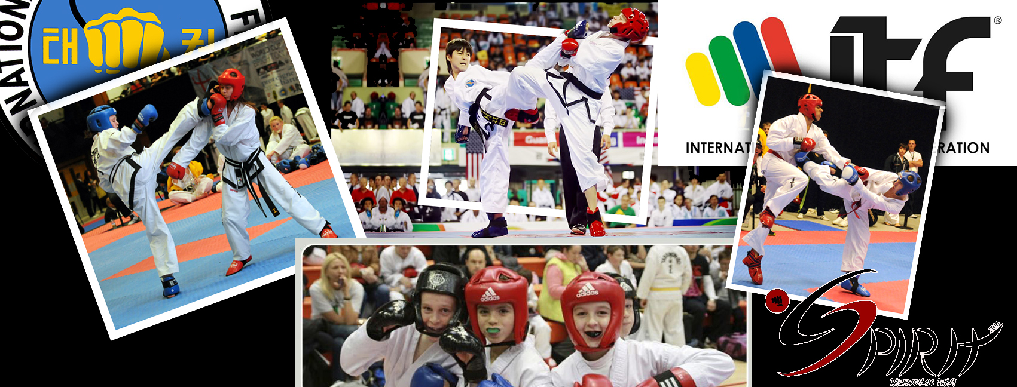
8th TOP TEN - SPIRIT OPEN
2019
BUDAPEST, HUNGARY

Competition: | 8th TOP TEN - SPIRIT OPEN – Open Taekwon-Do Championship – 2019
Organizer Association: | TKD Spirit Association
Head of Organizing Committee: | Péter Szász 6th Degree  +36-20-398-5391 e-mail: szasz.peter.tkd@gmail.com
Information: | spiritopen@tkdspirit.hu  www.tkdspirit.hu
Members of Tournament Committee | Attila Solti 5th Degree, László Kozák 6th Degree, Attila Gombos 5th Degree
Date of the Competition: | 6th April, 2019
Location of the Competition: | Budapesti Elektromos Művek Sports Hall  Address: 20 Népfürdő street, Budapest, H-1138  GPS coordinates: North latitude: 47.533774° East longitude: 19.0590281°
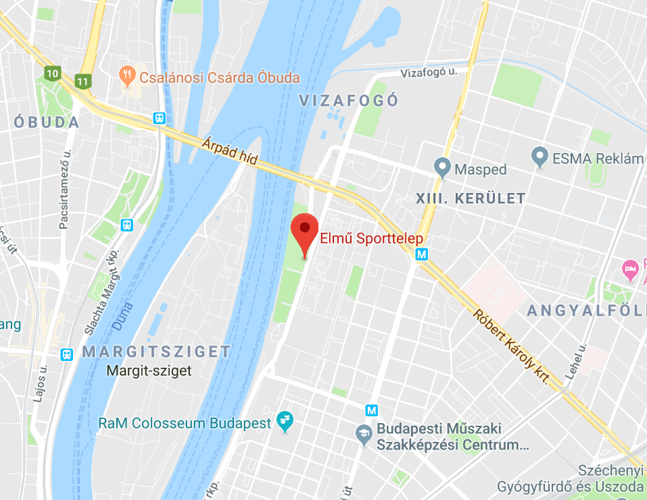
Divisions: | Child: born after 06.04.2009  Cadet: born between 06.04.2005 and 05.04.2009  Cadet-1 (only in Sparring): born between 06.04.2007 and 05.04.2009  Cadet-2 (only in Sparring): born between 06.04.2005 and 05.04.2007  Junior: born between 06.04.2001 and 05.04.2005  Senior: born before 06.04.2001  Veteran: born before 06.04.1979 (only in Sparring event. Veterans and Seniors will compete together in Pattern, Pre-arranged Free Sparring, Special Techniques Test and Power Test events. Veteran competitors can compete only in their own age category in Sparring, not in Senior category.)

Events: | Pattern (Child / Cadet / Junior / Senior categories for Taekwon-Do competitors only)  Sparring (based on the official ITF Taekwon-do rules in Child / Cadet-1 / Cadet-2 / Junior / Senior / Veteran categories)  Pre-arranged Free Sparring (based on the official ITF Taekwon-do rules in Junior / Senior categories, male-male, female-female or male-female pairs are also accepted.)  Individual Power Test (based on the official ITF Taekwon-do rules in Junior / Senior categories and for special cushioned force-measuring Power Test target in Child and Cadet categories)  Individual Special Techniques Test (based on the official ITF Taekwon-do rules in Junior / Senior categories)
Minimal belt degree for Pattern: | Child: 10 gup  Cadet: 9 gup  Junior: 8 gup  Senior: 8 gup
Awarding: | In Sparring at Child age category we will form groups of 4 children, so every Child competitor wins a medal (1 gold, 1 silver, 2 bronze).  In the other age categories and events 1 gold, 1 silver and 2 bronze medals will be given.  The three most successful clubs will receive trophies at the end of the competition.
Umpires: | Every ITF Taekwon-Do school or club with more than 5 competitors should bring umpires as far as possible.  Dress code for umpires: navy blue/black pants, white shirt, blue/black tie, white shoes.
Entry conditions: | Proper age.  Registration in time and the payment of registration fee.  Medical certificate for competitors taking part in sparring.

Registration fee: | Bank transfer with discount until 30.03.2019:  - Child / Cadet: 22 €  - Junior / Senior / Veteran: 27 €  Payment in cash on the spot without discount (full amount):  - Child / Cadet: 25 €  - Junior / Senior / Veteran: 30 €  ATTENTION! There is a possibility to transfer the entry fees to the Organizing Committee Bank account, but the club leader must start the bank transfer in the right time. The Organizing Committee cannot accept individual bank transfers from the competitors. Please fill the name of the Club in the announcement field at the bank transfer (the names of the competitors are not required, the amounts will be written to the competitors listed in the registration form). The Club leader must transfer the whole registration fee of the competitors to reach the discount (transferring sub-totals per competitors are not accepted). Please send the verification form of the bank transfer to the official e-mail address of the Organizing Committee (spiritopen@tkdspirit.hu)  The Organizing Committee cannot accept bank transfers started after 30.03.2019. The competitors added after 30.03.2019 (whose bank transfer could not arrive until the deadline) must pay the full amount of registration fee. The amount that may be missing from the bank transfer, must be paid by the Club leader in cash at the registration desk. The amounts arriving after 30.03.2019 cannot be taken into account by the Organizing Committee at the registration (these amounts will be transferred back after the competition).  Fees can only be accepted in HUF and € (Euro) currencies.  Bank account details to bank transfer:  Name: MIDGARD TEAM PRO Kft.  Address: 3000 Hatvan, Hatvany Irén utca 22. 2/6.  Tax nr.: 25508134-1-10  Account (EUR): 10700299-69554265-50000005  IBAN DEVIZA: HU55 10700299-69554265-50000005  SWIFT: CIBHHUHB  Bank: CIB Bank  Bank Address: 1027 Budapest, Medve u. 4-14.  Please remember to include the bank transfer cost. In case the cost of bank transfer is paid by the Organizing Committee, this amount must be purchased by the Club leader at the registration desk on the spot.
Registration deadline: | Registration deadline: midnight 03.04.2019  ATTENTION! The last moment to modify registration is 8:30 a.m. 06.04.2019. On-site registration is only possible for pre-registered clubs, but in this case every new competitor must pay the entry fee and modification fee as well. (15 €/modification/competitor)
Registration: | The registration for this event must be done online through Sportdata: https://www.sportdata.org/taekwondo_itf/set-online/index.php  The online registration is required, the Organizing Committee cannot accept any registration requests or changes in other ways, but if you need any help in connection with the registration please do not hesitate to contact us. (spiritopen@tkdspirit.hu)  Each club leader or coach has to register his club in the Sportdata system than has to register all of his competitors and than he can add the competitors to the event.  The registration will close at midnight on 03.04.2019, after this deadline changes can only be accepted with the conditions mentioned above.  Attention! In the case of Child sparring will be formed 1 boy and 1 girl sparring category in the Sportdata system. It is important that the required data should be given correctly by the coaches (age, belt, height) because the Child groups will be formed based on these data.
Weigh-in and On-site Registration: | All competitors of the club (participating in Sparring) must come to the Weigh-in in the same time, together. At the Weigh-in the club leader (or designee) must be there.  Competitors must wear ITF dobok trousers or sweat pants, T-shirt and must be barefoot or in socks. At the place of Weigh-in there is no time to undress.  A maximum of 500 grams margin over the indicated weight category is permitted. In case of more difference than 500 grams, competitor can switch weight category, but this will be a modification (mentioned above).  After Weigh-in the Club leader registers all the competitors at once at the Registration desk. The club leader must pay all the fees and possibly penalties in one lump sum to their competitors. Individual registration and entry fee payment is not possible. The competitors can start the competition if the club leader has already paid all the fees of the whole club and has got the armbands for the competitors. Every competitor must use the armbands. A competitor who does not have the armband will be excluded.

Event descriptions

Pattern
 | Child | Cadet
10-9-8-7 gup | Chon-Ji – Do-San | n/a
9-8-7 gup | n/a | Chon-Ji – Do-San
6-5-4 gup | Chon-Ji – Joong-Gun | Chon-Ji – Joong-Gun
3-2-1 gup | Chon-Ji – Choong-Moo | Chon-Ji – Choong-Moo
I.dan | n/a | Chon-Ji – Ge-Baek

 | Junior | Senior
8-5.gup | Chon-Ji – Yul-Gok | Chon-Ji – Yul-Gok
4-1.gup | Chon-Ji – Choong-Moo | Chon-Ji – Choong-Moo
I.dan | Chon-Ji – Ge-Baek | Chon-Ji – Ge-Baek
II.dan | Chon-Ji – Ju-Che | Chon-Ji – Ju-Che
III.dan | Chon-Ji – Choi-Yong | Chon-Ji – Choi-Yong
IV-VI.dan | n/a | Chon-Ji – Moon-Moo

This event will be organized as a round robin tournament in case of 3-competitors-group, but it will be organized as a knockout tournament in case of more than 3 competitiors in a group.
Child and Cadet competitors must present one pattern, which will be chosen by the referee during the qualifying round and the final too. The pattern cannot be higher than the lower belt degree of the competitors.
Junior and Senior competitors must present one pattern during the qualifying round and two patterns during the final, which will be chosen by the referee. In colour belt categories the pattern cannot be higher than the lower belt degree of the competitors, in black belt categories the pattern can be maximum 1 rate higher than the belt degree of the competitors.
Sparring

Organizing Committee will form 4-person groups in Child category for girls and boys separately based on age, weight, knowledge and experience. This event will be organized as a knockout tournament (direct eliminations system), in which each competitor wins a medal (1 gold, 1 silver, 2 bronze).
Other categories have weight categories for girls and boys / female and male separately. This event will be organized as a knockout tournament (direct eliminations system).
A competitor can only be registered in their proper age and weight category, it is not allowed to compete in two age or weight categories.
Weight categories:
Cadet-1 female (kg): | -27 | 27-32 | 32-38 | 38-44 | 44+
Cadet-2 female (kg): | -38 | 38-44 | 44-50 | 50-55 | 55+
Cadet-1 male (kg): | -30 | 30-35 | 35-42 | 42-48 | 48+
Cadet-2 male (kg): | -42 | 42-48 | 48-55 | 55-62 | 62+
Junior female (kg): | -45 | 45-50 | 50-55 | 55-60 | 60-65 | 65+
Junior male (kg): | -50 | 50-56 | 56-62 | 62-68 | 68-75 | 75+
Senior female (kg): | -50 | 50-56 | 56-62 | 62-68 | 68-75 | 75+
Senior male (kg): | -57 | 57-63 | 63-70 | 70-78 | 78-85 | 85+
Veteran female (kg): | -65 | 65+
Veteran male (kg): | -75 | 75+
Sparring times:
 | Child | Cadet-1/-2 | Junior | Senior | Veteran
Qualifying round: | 1 X 1.5 minutes | 1 X 2 minutes | 1 X 2 minutes | 1 X 2 minutes | 1 X 2 minutes
Final: | 1 X 1.5 minutes | 1 X 2 minutes | 2 X 2 minutes | 2 X 2 minutes | 2 X 2 minutes
Rest time between the rounds: 1 minute.
In case of the number of competitors is less than two (2) in a category, organizers might decide to combine categories by the consent of the competitor's coaches.
General rules of sparring
This is a Light contact sparring based on ITF Taekwon-Do rules. Attacks can happen with half power and controlled manner. The body and head can be attacked from the front and from the side, the side of the neck can be attacked with fists, feet, heels, and end of the tibia. Only the open side attacks are allowed. Only the section above the belt (over hip height) can be attacked. A competitor who is aggressive, very violent or using excessive forced techniques will be warned or disqualified.

Scoring:
- 1 point awarded for all hand techniques
- 2 points awarded for foot techniques to the body
- 3 points awarded for foot techniques to the head
- Only those hits can be scored which are controlled, precise, quick and performed with sufficient force (light contact).
Allowed surfaces to attack:
- Head at the front, sides and top of the head but not at the back.
- Trunk of the body from shoulder to the waist (frontal and side areas only, excluding the back)
Disqualification  - Misconduct against officials or ignoring instructions.  - Uncontrolled or excessive contact.  - Receiving three (3) minus points/fouls directly given by the Centre Referee.  - Being under influence of alcoholic beverages or drugs. | Point reduction  One point will be deducted for the following offences:  - Insulting the opponent  - Losing calm  - Biting, scratching  - attacking with elbow, knee, head  - Attacking a fallen opponent  - Attacking forbidden surfaces on the opponent  - Three warnings means deducting one point.  - Holding/grabbing  - Heavy contact  - Leg sweeping | Warning  - Unintentional attack to forbidden surfaces on the opponent  - Stepping completely out of the ring (both feet).  - Falling down, whether intentional or not (it means any part of the body, other than the feet, touching the ground).  - Pushing the opponent  - Pretending to be injured to gain an advantage.  - Intentionally avoiding sparring.
The process of the sparring
Competitors wearing mandatory protection equipment must stand on the appointed place to begin the sparring (red and blue sides). Competitors will be differentiated with a red and a blue stripe on the back side of their clothes. Based on the command of the referee they will bow to jury or to the umpires and towards each other. The sparring begins after the command of the referee („SHI-JAK”). The competitors will fight until the end of the round or the command of the referee („HAECHYO”). In this case the competitors must stop sparring and stay in place till the referee restart the sparring with the „GAE-SOK” command. The round is over with the command of the referee („GOMAN”). At the end of the sparring the competitors must bow towards each other, to jury or to the umpires and to the referee. The competitors stay in place till the referee signs the result. If the score is equal, the warnings and minus points will be cleared.
Pre-arranged Free Sparring
Only for Junior and Senior categories. In this category the compilation of pairs can be optional: male, female, mixed couples.
Umpires score the practice, based on the score will be formed the order. In case of draw competitors need to perform the practice again, which will be rescored by umpires (except in case of the two third places).
Competitors must perform their movements between 60 and 75 seconds. Pre-arranged free sparring will be held on the basis of ITF Taekwon-Do rules.
Individual Special Techniques
Only for Junior and Senior categories.
 | Twimyo nopi chagi | Twimyo dollyo chagi | Twimyo bandae dollyo | Twimyo dolmyo yop cha jirugi | Twimyo nopi yop chagi
Junior Female | 200 | 180 |  |  | 100
Junior Male | 230 | 210 | 200 | 200 | 130
Senior Female | 210 | 190 |  |  | 110
Senior Male | 240 | 220 | 210 | 210 | 140
Special Technique test will be performed using special technique machine. After performing the three or five techniques the summary of the points will show the outcome of the event.
Special Technique tests are taking place continuously throughout the competition day. Attention! Every competitor must perform the first round of the Special Technique test until 3 p.m. Final will be held after 3 p.m. The competitor who does not perform the first round of Special Technique test until 3 p.m, will be disqualified.
Individual Power Test
For Junior and Senior categories:
 | Ap-joomuk jirugi | Songkal tearigi | Yop chagi | Dollyo chagi | Bandae dollyo chagi
Junior Female |  | 1 | 2 | 1
Junior Male | 1 | 1 | 2 | 1 | 1
Senior Female |  | 1 | 2 | 1
Senior Male | 2 | 2 | 3 | 2 | 2
Power test will be performed using power test machine to white breaking board. After performing the three or five tests the summary of the points will show the outcome of the event.
Power Tests taking place continuously throughout the competition day. Attention! Every competitor must perform the first round of the Power Test until 3 p.m. Final will be held after 3 p.m. The competitor who does not perform the first round of Power Test until 3 p.m, will be disqualified.
For Child and Cadet categories:
The techniques must be performed at a special cushioned force-measuring Power Test target. Every competitor can hit and kick the target twice and the stronger value will be taken into account. The final score of the competitor will be formed by summing up the values of the two techniques.
 | Songkal yop tearigi | Dollyo chagi (baldung)
Child Female | 1 | 1
Child Male | 1 | 1
Cadet Female | 1 | 1
Cadet Male | 1 | 1

Equipment
Clothes
ITF Taekwon-Do competitors can only wear white ITF dobok. Kickboxing and other competitors might wear their own uniform.
Clothes cannot contain any zip, button, snap, etc. which can cause injury.
Protection equipment
Mandatory: Open hand or 10 once closed gloves, boots and head protector. Groin protector and mouth protector for Junior, Senior and Veteran.
Suggested: shin guards, bust-protector for Junior and Senior Female.
Further information
The way of making a protest is based on ITF Taekwon-Do rules. Any official written protest must be declared to the Tournament Committee within 5 minutes after the incident happened. Protests will have a cost of 50 €. The Tournament Committee will decide about the acceptance of the protest. The fee paid is not refundable in case of rejection of the protest.
The Organising Committee do not take responsibility for any sport injuries during the competition.
Every coach or club leader is responsible for the medical certificate and the health status of the competitors.
Accident insurance is recommended.
Competitors take part in the competition at their own risk (under the age of 18 with parental permission). The Organising Committee does not check the parental permissions, this is the responsibility of the club leader.
During the competition medical care is provided.
Ticket for the spectator: 2 EUR / person
8th Spirit Open competition T-Shirt, Taekwon-Do uniforms and equipment (gloves, kicks, shoes, belts, mouthguards, headguards...) can be bought during the competition.

Stamping of the books will be from 4 p.m. on the competition day at the registration desk.
The Organizing Committee does not coordinate booking accommodation and the transfers to the accommodation or to the Sports Hall.
Planned program
06.04.2019 Saturday | 7:00 a.m. - 8:30 a.m. | Registration, weigh-in in the Sports Hall (8:30 a.m. is the last moment for the clubs to come to the weigh-in.)
 | 8:45 a.m. | Closing of registration and weighing (From this time there is no more chance to registration, weigh-in or modification.)
 | 8:45 a.m.-9:00 a.m. | Umpire meeting
 | 9:00 a.m.-9:15 a.m. | Coach meeting
 | 9:15 a.m.-09:30 a.m. | Opening ceremony
 | around 09:30 a.m. | Beginning of the competition
There is no lunch break
The first awarding ceremony will be held around 12:00 a.m., and others will follow continuously during the afternoon.
This is the planned program, but the Organizing Committee reserve the right to change the program.
